The Following diagrams represent the first four figures in a pattern. What mathematical questions could arise from this?

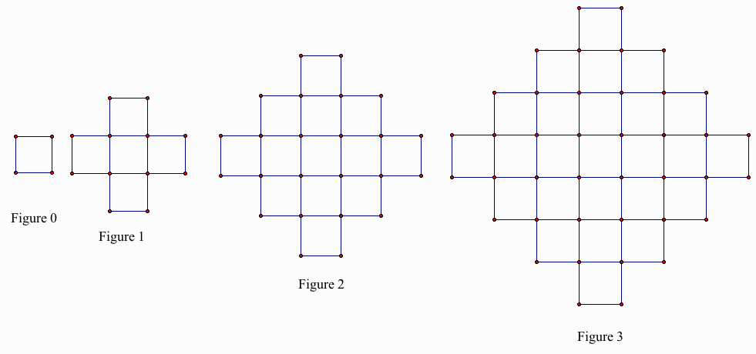
What happens if we look at the number of sticks necessary to make each of these? How many sticks will be needed for the 5th stage? What about the 10th stage? And finally, how many will you need for the nth stage?
Let’s count the perimeter of these steps. How many sticks will be needed for the 5th stage? What about the 10th stage? And finally, how many will you need for the nth stage?

Counting the vertices, how many dots are needed for each figure? How many vertices will be needed for the 5th stage? What about the 10th stage? And finally, how many will you need for the nth stage?
Now, how about area of the figure if we let each small square represent one square unit…

