Goal: Devise some specific ways of talking about the cognitive demand of a task, and connect it to the purpose of students doing a task. Include the idea that tasks can provide opportunities for meaningful mathematical discourse and productive struggle.

Individually, then discuss in your PLC: What do we mean when we talk about the ‘cognitive demand’ of a task? Jot down a few ideas you look for when looking at the cognitive demand of a task.

Sort tasks from lowest to highest cognitive demand, and while you discuss them, write down the characteristics you use to discuss the cognitive demand of a task.

Low cognitive demand:

High cognitive demand:

Discussion of higher demand tasks:
- In what ways do the tasks you identified as higher level support coherent and focused learning, helping students make connections between concepts and procedures?
- In what ways can the tasks provide opportunities for meaningful mathematical discourse? Specifically, what aspects of each higher-level task is problematic for students mathematically?
- What opportunities are there for students to engage in and reflect on their use of the SMP?

Task A (from Engage NY Algebra 1)
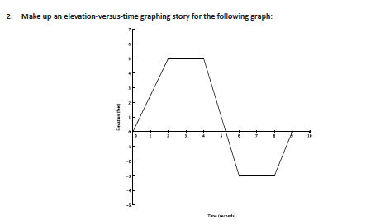

Task B (from Engage NY Algebra 1)

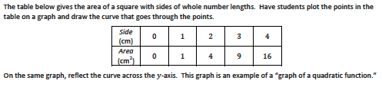

Task C (from Engage NY Algebra 1)
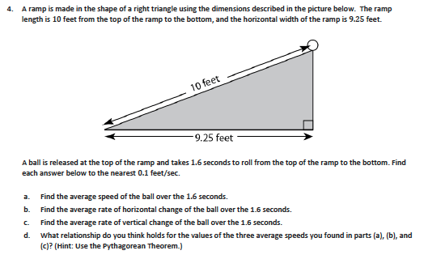

Task D (from Engage NY Algebra 1)

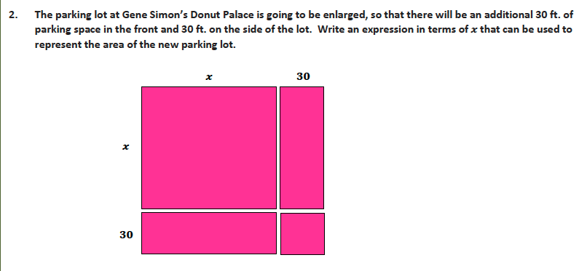

Task E (from Kuta Software – Infinite Algebra 1)
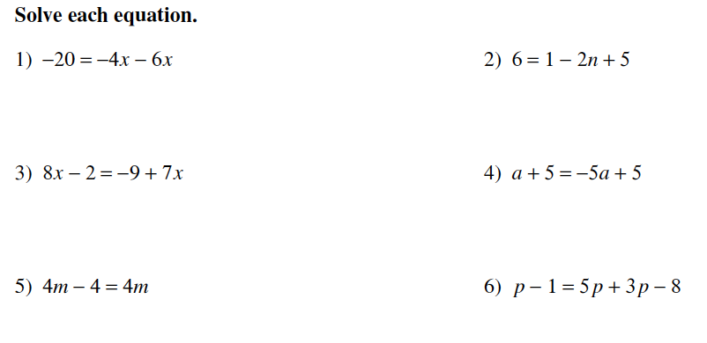

Task F (from Engage NY Algebra 1)
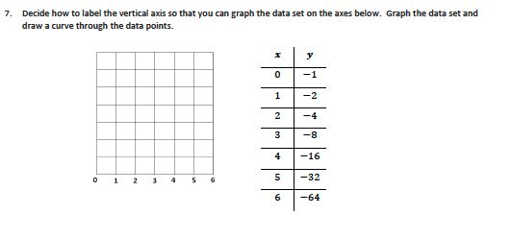

Task G (from Engage NY Algebra 1)
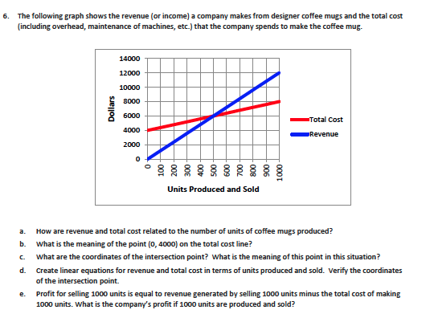

Task H
Solve the equation $\frac{y+x}{6}=\frac{A}{h}$ for x.

Task I
Write four exponential expressions, one for each of the following criteria. All the expressions should simplify to $2^{\text{50}}$.
  - Written as a product
  - Written as a sum
  - Written as a difference
  - Written as a quotient

Task J

You study buddy was solving the following equation: $\left(x−5\right)\left(x+2\right)=1$. He first set each factor equal to 1, justifying that 1 times 1 is 1, then solved for x in each equation: $x−5=1$ or $x+2=1$, so $x=6$ or $x=−1$. Is your study buddy right or wrong? Explain, using a mathematical justification.

